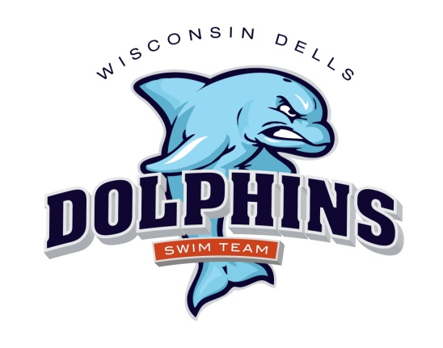

2019 Dells Dolphins Swim Team Schedule
(Home meets are in red)

June 8, Saturday Home vs Mazo 8:00 a.m.
June 15, Saturday Home vs Sun Prairie 8:00 a.m.
June 22, Saturday Home vs Sauk Prairie 8:00 a.m.
June 26, Wednesday Away vs. Spring Green 6:00 p.m.
July 2, Tuesday Home vs Mt. Horeb 6:00 p.m.
July 13, Saturday Away vs Cross Plains 8:00 a.m.
July 20, Saturday Away vs. Baraboo 8:00 a.m.
July 27 & 28: Dells Dolphins hosts Conference
At Baraboo Pool

Swimmers: Swimmers: For home meets, you must arrive and be prepared to be in the water for warm-ups one hour prior to the start of the meet. For away meets, you must arrive and be prepared to warm up ½ hour prior to the start of the meet. Please arrive early! If you are late for warm-ups, you may be cancelled from some/all of your events.

