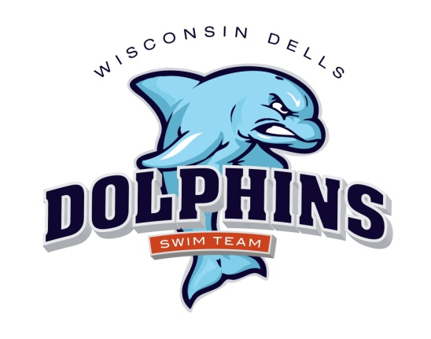
2019 Dells Dolphins Code of Conduct

Swimmers Will, At Practices and Meets:
- Arrive at practice allowing enough time to begin on time.
- Bring WATER to every practice and meet! It is important to stay hydrated!
- Respect and encourage all the swimmers on the team.
- Behave and speak appropriately in the locker room.
- Absolutely NO CELL PHONE USE in the locker rooms/bathrooms.
- Work hard at every practice, including dryland and water.
- Remain silent and make an honest effort to listen and look when coaches are talking.
- Be responsible and helpful for the care and use of all equipment, and know that practice is not over until ALL of the equipment is picked up and put away, whether you used it or not.
- Set reasonable and attainable goals for training and meet performance.
- Know your best times in each of your events.
- Go to the coach first with questions or concerns.
- Know what events you are swimming at the meet and have your arm or leg marked.
- Be on time for meet warm-ups for your session.
- Have an extra swimsuit, cap and set of goggles at meets, in case yours break.
- Encourage and cheer on your teammates and congratulate swimmers with whom you swim.
- Find JOY in your teammates accomplishments, and “lift them up” when they are struggling.

Parents Will:
- Familiarize yourself with the Dells Dolphins website. Most of the information we share with you will be on this website!
- Sign up for swim meets, on the form provided by the coach, by the listed deadline. Please note that YOU are responsible to submit your swimmers’ requested events to the head coach on the form provided. If you have any questions, please talk to the coach. The coach has the ultimate decision regarding the events your swimmers swim.
- Read the event sheets carefully so you know how many events to sign up for.
- Encourage your child to follow all of the expectations above.
- Help and encourage your child to eat healthy, get enough sleep/rest and stay hydrated.
- Praise your child for completing practices and meets, whether they reach specific goals or not.
- Be positive and encouraging to all of the swimmers on the team, at both practices and meets.
- Be respectful and supportive of the team in public and on social media.
- Respect the coaches at meets and practices by staying off deck and speaking with coaches either before or after (not during) practices.
- If you have a question, comment, or concern about the team or your swimmer, please speak to the head coach. We are all here to help your child and the team, be the best they can be. Negative comments do not enforce team unity or personal best performances.
- Pay all fees in a timely manner.

We are a part of the Dells Dolphins Swimming Family. We agree to follow the expectations above. If we have any questions or concerns during the season we will approach a board member or coach.

2019 Dells Dolphins Code of Conduct
Acknowledgement Form

PLEASE READ THE 2019 DELLS DOLPHINS CODE OF CONDUCT. PRINT THIS PAGE, SIGN BELOW, AND TURN IT IN WITH REGISTRATION FORMS. KEEP THE CODE OF CONDUCT AT HOME FOR REFERENCE.

SWIMMERS (sign below):

I have read and understand what is expected of me in the 2019 Dells Dolphins Code of Conduct. (Swimmer Printed Name) ________________________________
(Swimmer Signature) _________________________________________________

I have read and understand what is expected of me in the 2019 Dells Dolphins Code of Conduct. (Swimmer Printed Name) ________________________________
(Swimmer Signature) _________________________________________________

I have read and understand what is expected of me in the 2019 Dells Dolphins Code of Conduct. (Swimmer Printed Name) ________________________________
(Swimmer Signature) _________________________________________________

PARENTS (sign below):

I have read and understand what is expected of me in the 2019 Dells Dolphins Code of Conduct. (Parent/Guardian Printed Name) ____________________________
(Parent/Guardian Signature) _____________________________________________

DATE: ______________________

