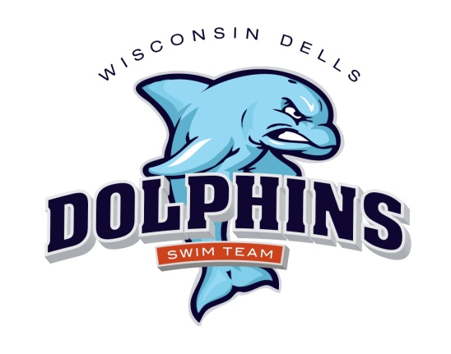

March 1, 2019

Dells Dolphins Swim Team Families:

A new swim team season is upon us, and it is sure to be filled with fun and excitement! For those of you who are veterans to our program, thank you for making the commitment. We appreciate the time and effort you put in to help ensure a smooth and successful season. For those of you who are new to our program, “Welcome!”. We hope you and your swimmers enjoy this experience.

Attached are the following items pertaining to the 2019 Dells Dolphins Swim Team season. If you wish to pre-register, please fill out these forms and return them to me via email, or mail. My contact information is provided below. You may send your payment with the forms or submit payment at registration.

- MARCH 14TH 5-7:30 – PARENT MEETING WITH QUESTION AND ANSWER SESSION, REGISTRATION, SIGN UP FOR MEETS AND CONFERENCE. THIS WILL BE HELD AT THE KILBOURN PUBLIC LIBRARY COMMUNITY CENTER.

- Registration Form: Please provide as much information as possible. This form must be filled out in order for swimmers to begin practice for the season. Do not fill in the shaded areas.

- Registration dates: March 14th 5-7:30PM or First three days of practice at the Wellness Center 4/1-3 &4 from 6:00-7:30

- Release of Liability, Emergency Treatment and Photo Release Form: This form must be filled out in order for swimmers to begin practice for the season.

- Code of Conduct: This form must be filled out by swimmers and parents in order for swimmers to begin practice for the season.

- Meet Schedule

- Practice Schedule

- Swim Suit Fitting: Monday April 8th 5-7:30pm at Ho-Chunk Wellness Center

- Picture Day: June 19th starting with group picture at 8:30am
- Swim Team caps are available for $13.50 each but are not required.
- White T-shirt for making conference t’s in July – parents to provide for their children

Team swimsuit fitting and apparel ordering will be held on Monday April 8th from 5-7:30p.m. at the Ho-Chunk Wellness Center before and during practice. A team suit is appreciated, if you have one from previous years that’s acceptable. If you don’t have a team suit, a plain dark blue or black suit is acceptable. Dells Dolphins participation fees are due at this time (if not submitted prior). Participation fees consist of the following: MORE INFO TO FOLLOW

- Spring Registration Fee: Fees depend on number of nights and swimmers. Payable to Wisconsin Dells Dolphins

- Summer Registration Fee: Payable to Wisconsin Dells Dolphins

- Concessions Fee: $40 per family. Payable to Wisconsin Dells Dolphin

- Conference $200 Deposit Check: Payable to Wisconsin Dells Dolphins. Dells Dolphins HOST the Conference Swim Meet this year and ALL families must be on deck to help! We are requiring each family to work two sessions at the Conference Swim Meet. IF a family fails to work the two sessions, we will cash this $200 check. IF a family meets the two required sessions of work, this $200 check WILL NOT BE CASHED! We will have a sign up sheet at registration and practices listing the jobs and contributions that qualify for the two, required work sessions.

- Pool Pass Fee: All Dells Dolphins swimmers must purchase valid pool passes from the Wisconsin Dells Parks and Recreation Association. Passes may be purchased at the Wisconsin Dells Municipal Pool. If you pay by check, it must be a separate check from your Dells Dolphins registration/concessions payment. Make pool pass checks payable to "City of Wisconsin Dells." All swimmers must have valid pool passes before the start of practices at the Wisconsin Dells Municipal Pool. There are Resident and Non-resident fees. To be considered a resident, one must pay taxes to the City of Wisconsin Dells or Village of Lake Delton.

The pool pass includes a Pool Party and Movie TBD. There will be live entertainment, free swimming and a “Movie in the Park” following at Veteran’s Park.

Resident Individual: $52 Non-Resident Individual: $68
Resident Family: $93 Non-Resident Family: $115

Please also visit www.dellsdolphins.com AND “like” our Facebook page. All the information provided in this letter can also be found on these sites. In addition, We will post swimmer/event information before each meet and meet results. We continuously update these sites to provide you with the most current and relevant information.

If you have any questions, please contact myself or a Dells Dolphins board member. We look forward to a prosperous season!

Sincerely,

Cynthia Ewig

Cynthia L Ewig
President
W14393 Valley View Ct.
Wisconsin Dells, WI 53965
cynthiaewig@yahoo.com
Cell: 608-963-5715

