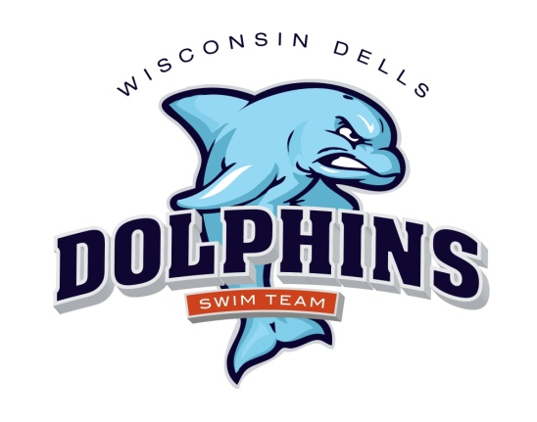

2019 Dells Dolphins
Practice Schedule

Spring Practice April
Ho Chunk Wellness Center - Baraboo

1 day/week – $60 2 plus – $110
A new swimmer to the club will receive half off on registration per swimmer fee.

April 1 through June 7
See Calendar for dates and times

Summer Practice – Dells Outdoor Municipal Pool

Registration: $30 per swimmer, plus $40 per family concessions fee
A new swimmer to the club will receive half off on registration per swimmer fee.

Practice begins June 10 – This could change
Monday through Friday

Time Age Groups
8:00 – 9:30 a.m. 11 & UP
9:30-11:00 a.m. 9-10
10:00-11:00 a.m. 8 & Under

5-6pm Tuesday, Wednesday, Thursday for all swimmers who couldn’t make an am practice and need extra help

A dryland component will be incorporated into every workout – please bring
appropriate clothing, socks and tennis shoes.

