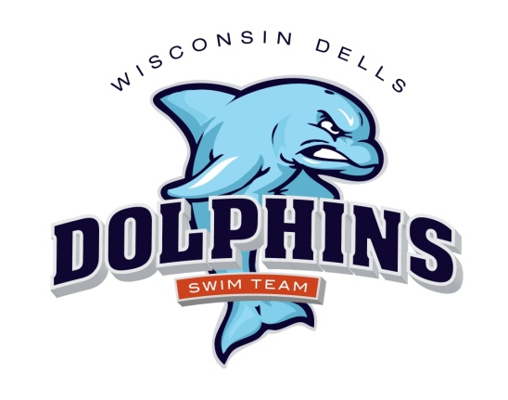

2022 Dells Dolphins Swim Team Schedule
(Home meets are in red)

June 8, Wednesday Home vs Spring Green 6:00 p.m.
June 11, Saturday Away vs Sun Prairie 8:00a.m.
June 18, Saturday Away vs Sauk Prairie 8:00 a.m.
July 2, Saturday Away vs. Mt. Horeb 8:00 a.m.
July 9, Saturday Home vs Cross Plains 8:00 a.m.
July 16, Saturday Home vs Baraboo 8:00 a.m.
July 23, Saturday Away vs. Mazo 8:00 a.m.
July 30-31 Conference Dual meet @Sauk Prairie Mazo hosting 8:00 a.m.

Swimmers: Swimmers: For home meets, you must arrive and be prepared to be in the water for warm-ups one hour prior to the start of the meet. For away meets, you must arrive and be prepared to warm up ½ hour prior to the start of the meet. Please arrive early! If you are late for warm-ups, you may be cancelled from some/all of your events.

