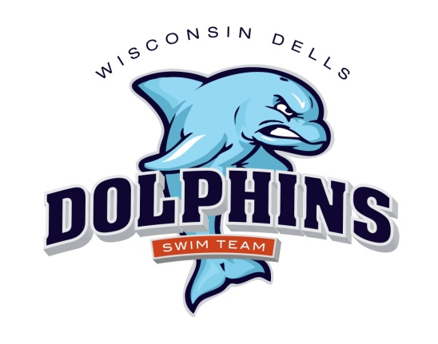

2022 Dells Dolphins
Practice Schedule

Spring Practice April & May
Mauston High School & Jack Young Baraboo

1 day/week – $85 2 plus – $135
A new swimmer to the club will receive half off on registration per swimmer fee.

April 3 through May 26
See Calendar on website for dates and times
Sunday – 5:30-7:30 p.m. Baraboo Jack Young
Tuesday – 5:00-6:00 p.m. Mauston High School
Thursday- 5:00-6:30 p.m. Mauston High School

Summer Practice – Dells Outdoor Municipal Pool

Registration: $100 per swimmer, discounts for multiple swimmers from one family see registration form
A new swimmer to the club will receive half off on registration per swimmer fee.

Practice begins June 6 – This could change
Monday through Friday

Time Age Groups
7:30– 9:00 a.m. 11 & UP
8:30 - 9:45 a.m. 10 & Under

5-6pm Tuesday, Wednesday, Thursday (check website calendar this is NOT all days) for all swimmers who couldn’t make an am practice and need extra help

A dryland component will be incorporated into every workout – please bring
appropriate clothing, socks and tennis shoes.

