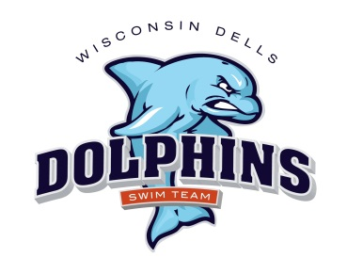**Dells Dolphins Swim Team 2023 Golf Outing Fundraiser**

**All proceeds go to the Dells Dolphins Swim Team**

**Where: Spring Brook Resort**

**When: Thursday, June 1st-2023**

**Shotgun start at 4:15 p.m. (nine holes – four-person scramble)**

**Registration: 3:00 – 4:00 PM (pre-registration is suggested)**

**Sponsorship Opportunity (please circle**)**: Dolphin $300, Minnow $200, Guppy $100**

**Bundled Donation $550 (Dolphin sponsor & foursome golf)**

**Business Name:**

**Contact:**

**Address:**

**Phone / Email:**

**Individual Golfers: $65 each Sponsor a Foursome: $260**

**Dinner Option Sirloin Steak or Chicken Cordon Bleu – indicate below for each**

**Golfer Name:**

**Golfer Name:**

**Golfer Name:**

**Golfer Name:**

**Donations for Raffle Prizes for Golf Outing** (please list donations along with corresponding value)**:**

Please return this form and payment by May 15/2023 to:

**Cynthia Ewig, W14393 Valley View Ct, Wisconsin Dells, WI 53965**

Make checks payable to: **Dells Dolphins Swim Team.**

Contact Cynthia (608-963-5715) with any questions or to have your donations picked up.

**Thank you for your support of the Dells Dolphins Swim Team!**