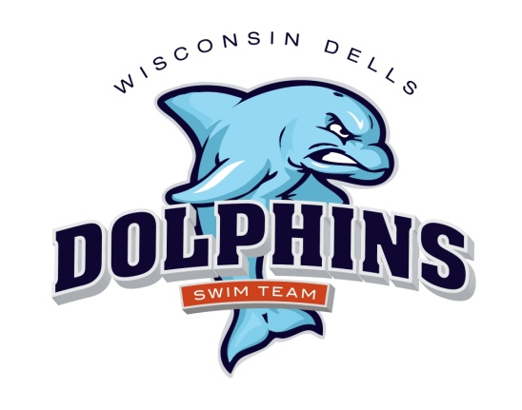

2024 Dells Dolphins Swim Team Schedule
(Home meets are in red)

June 8 Saturday Home vs Spring Green 8:00 a.m.
June 15 Saturday Away vs Mt Horeb 8:00a.m.
June 22 Saturday Home vs Cross Plains
June 26 Wednesday Away vs Mazo 6:30 p.m.
June 29 Saturday Home vs Baraboo 8:00 a.m.
July 13 Saturday Away vs Sun Prairie 8:00 a.m.
July 20 Saturday Away vs Sauk Prairie 8:00 a.m.
July 27-28 Conference Dual meet @Sun Prairie Sun Prairie hosting 8:00 a.m.

Swimmers: Swimmers: For home meets, you must arrive and be prepared to be in the water for warm-ups one hour prior to the start of the meet. For away meets, you must arrive and be prepared to warm up ½ hour prior to the start of the meet. Please arrive early! If you are late for warm-ups, you may be cancelled from some/all of your events.

