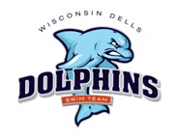
2024 Dells Dolphins
Practice Schedule

Jack Young Middle School-Baraboo

1 day/week – $100 2 plus – $135
A new swimmer to the club will receive half off on spring registration per swimmer fee.

April 7 through May 31
See Calendar on website for dates and times.
Sunday: 6:30 - 8:30 pm Baraboo Jack Young – April 7&14
Sunday: 6:00 - 8:00 pm Baraboo Jack Young – April 21, 28 – May 5, 12, 19

***ADDED***
Spring Practice April & May
Rusch Community Pool-Portage

April 2 through May 21
Tuesdays & Thursdays: 4:30 - 5:45 pm Rusch Community Pool
Note: NO practice on April 11th due to suit fitting at Baraboo Pool

Address: 117 West Franklin St. Portage, WI 53901

