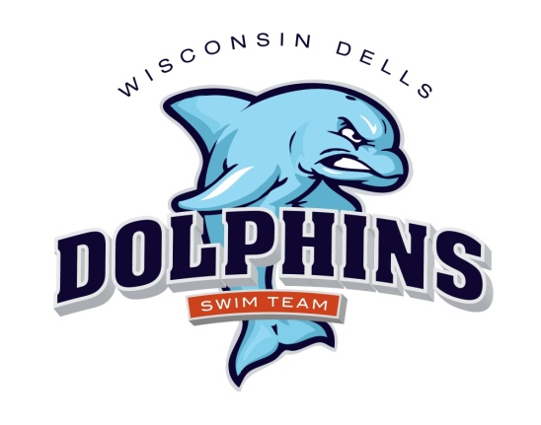

March 13, 2025

Dells Dolphins Swim Team Families:

A new swim team season is upon us, and it is sure to be filled with fun and excitement! For those of you who are veterans to our program, thank you for making the commitment. We appreciate the time and effort you put in to help ensure a smooth and successful season. For those of you who are new to our program, “Welcome!”. We hope you and your swimmers enjoy this experience.

Attached are the following items pertaining to the 2025 Dells Dolphins Swim Team season. If you wish to pre-register, please fill out these forms and return them to me via email, or mail. My contact information is provided below. You may send your payment with the forms or submit payment at registration.

* MARCH 18th 4:30-6:30pm – THIS WILL BE AN OPEN HOUSE FORMAT WITH BOARD MEMBERS PRESENT TO ANSWER QUESTIONS, REGISTRATION, PARENTS SIGN UP FOR WORKING MEETS, THIS WILL BE HELD AT THE KILBOURN PUBLIC LIBRARY IN THE COMMUNITY CENTER.
* **Registration Form:** Please fill out the form completely. This form must be filled out completely for swimmers to begin practice for the season. Do not fill in the shaded areas. Remember to sign and include your child’s t-shirt size
* **Registration dates: March 18th 4:30-6:30 pm or the first day of practice at Baraboo April 6th 6:00-8:00 pm.**
* **Release of Liability, Emergency Treatment and Photo Release Form:** This form must be filled out and turned in prior to their first practice day in the pool. They will not be allowed in the pool without this form completed. **This** **will need to be completed and turned in before child can enter the pool.**
* **Code of Conduct:** This form must be filled out by the swimmer and the parent. This must be turned in prior to first practice day in the pool. They will not be allowed in the pool without this form completed.
* **Meet Schedule**
* **Practice Schedule**
* **Swimsuit Fitting: April 24th 4:00-6:30 pm at the Jack Young Middle School , Baraboo Pool**
* **Picture Day: June 18th – 7:30 am group picture, individuals to follow**.
* **Swim Team caps are available for purchase at practices or swim meets, otherwise order from Simply Swimming**
* **White T-shirt for making conference t’s in July – parents to provide for their children.**

Team swimsuit fitting and apparel ordering will be held April 24th at Baraboo Pool. A team suit is appreciated. If you have one from previous years that’s acceptable. If you don’t have a team suit, a plain dark blue or black suit is acceptable.

Dells Dolphins participation fees are due at this time (if not submitted prior). Participation fees consist of the following: **MORE INFO TO FOLLOW**

* **Spring Registration Fee**: Fees depend on number of nights and swimmers. Payable to Wisconsin Dells Dolphins
* **Summer Registration Fee**: Payable to Wisconsin Dells Dolphins
* **Deposit check of $150 required at registration: Payable to Wisconsin Dells Dolphins. (This check will be returned to you as long as your family works at least two meets.) Dells Dolphins hosts four home meets, and it takes roughly 25 people for each meet to run it. A sign-up email will come out and you can sign up for the season. It’s your responsibility to let me know when your family has worked two meets so I can return your check. Each family will be required to work at least two meets, or you will forfeit your deposit check of $150. We need all parents on deck to help run the meets, that’s why we are implementing a required deposit.**
* **Pool Pass Fee**: All Dells Dolphins swimmers must purchase valid pool passes from the Wisconsin Dells Parks and Recreation Association. Passes may be purchased at the Wisconsin Dells Municipal Pool. If you pay by check, it must be a separate check from your Dells Dolphins registration. Make pool pass checks payable to “City of Wisconsin Dells.” All swimmers must have valid pool passes before the start of practices at the Wisconsin Dells Municipal Pool. There are Resident and Non-resident fees. To be considered a resident, one must pay taxes to the City of Wisconsin Dells or Village of Lake Delton. You can do this online or at the pool once it’s open.

**2025 Pool Pass Fees:**

**Resident Individual: $66 - TBD Non-Resident Individual: $83 - TBD**

**Resident Family: $109 - TBD Non-Resident Family: $132 - TBD**

Please also visit [www.dellsdolphins.com](http://www.dellsdolphins.com) AND “like” our Facebook page. All the information provided in this letter can also be found on these sites. In addition, We will post swimmer/event information before each meet and meet results. We continuously update these sites to provide you with the most current and relevant information.

If you have any questions, please contact myself or a Dells Dolphins board member. We look forward to a prosperous season!

Sincerely,

Cynthia Ewig

Cynthia L Ewig

Co-President - outgoing

W14393 Valley View Ct.

Wisconsin Dells, WI 53965

[cynthiaewig@yahoo.com](mailto:jcdiehl@tommybartlett.com)

Cell: 608-963-5715

Amy Gavinski

President – Incoming

[Amygavinski@gmail.com](mailto:Amygavinski@gmail.com)