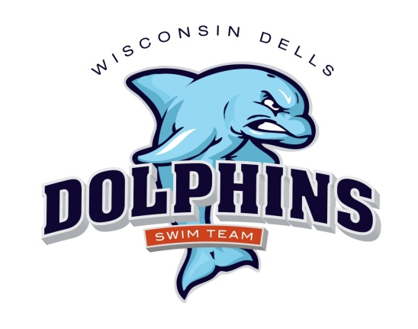

**2025 Dells Dolphins Swim Team Schedule**

**(Home meets are in red)**

**June 7 Saturday Home vs Mt Horeb 8:00 am**

**June 14 Saturday Away vs Mt Cross Plains 8:00 am**

**June 21 Saturday Away vs Baraboo 8:00 am**

**June 28 Saturday Home vs Mazomanie 8:00 am**

**July 2 Wednesday Home vs Sun Prairie 6:00 pm**

**July 12 Saturday Home vs Sauk Prairie 8:00 am**

**July 19 Saturday Away vs Spring Green 8:00 am**

**July 26-27 Conference Dual meet 8:00 am**

**Mt Horeb hosting 8:00 a.m.**

**Swimmers: For home meets, you must arrive and be prepared to be in the water for warm-ups one hour prior to the start of the meet.**

**Swimmers: For away meets, you must arrive and be prepared to warm up ½ hour prior to the start of the meet.  Please arrive early! If you are late for warm-ups, you may be cancelled from some/all of your events.**