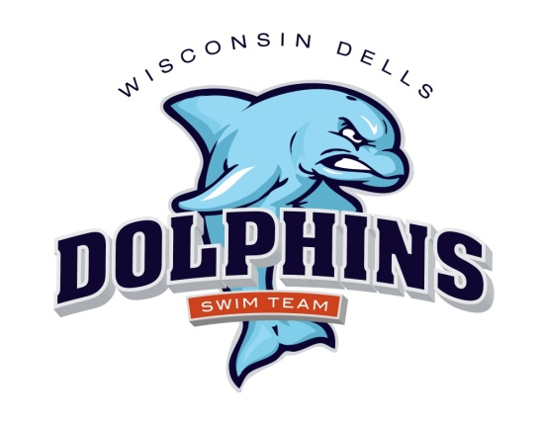

2026 Dells Dolphins
Practice Schedule

Spring Practice April & May
Jack Young Baraboo

1 day/week – $100
A new swimmer to the club will receive half off on registration per swimmer fee.

April 10 through May 17
See Calendar on website for dates and times
Sunday – 6:00-8:00 p.m. Baraboo Jack Young – April 12,19,26
May 3,10,17
Friday – 4:30-6:30 p.m. Baraboo Jack Young – April 10,17,24
May 1,8,15

Summer Practice – Dells Outdoor Municipal Pool

Registration: $100 per swimmer, discounts for multiple swimmers from one family see registration form
A new swimmer to the club will receive half off on registration per swimmer fee.

Practice begins TBD – This could change
Monday through Friday

Time Age Groups
7:30– 9:00 a.m. 11 & UP
8:30 - 9:45 a.m. 10 & Under

5-6pm Tuesday, Wednesday, Thursday (check website calendar this is NOT all days) for all swimmers who couldn’t make an am practice and need extra help

A dryland component will be incorporated into every workout – please bring
appropriate clothing, socks and tennis shoes.

