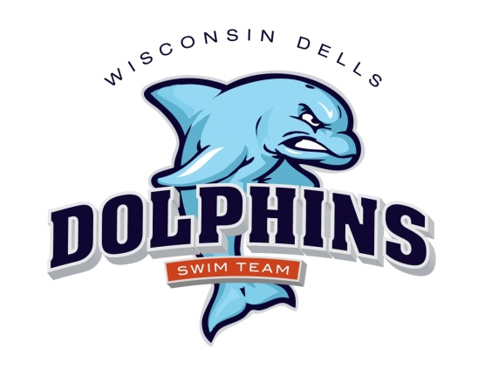

2026 Dells Dolphins Swim Team Schedule
(Home meets are in red)

June 6 Saturday Home vs Cross Plains 8:00 am
June 13 Saturday Home vs Baraboo 8:00 am
June 20 Saturday Away vs Mazo 8:00 am
June 27 Saturday Home vs Sun Prairie 8:00 am
July 1 Wednesday Away vs Sauk Prairie 5:00 pm
July 11 Saturday Home vs Spring Green 8:00 am
July 18 Saturday Away vs Mt Horeb 8:00 am
July 25-26 Conference Dual meet 8:00 am
Spring Green hosting 8:00 a.m.

Swimmers: For home meets, you must arrive and be prepared to be in the water for warm-ups one hour prior to the start of the meet.

Swimmers: For away meets, you must arrive and be prepared to warm up ½ hour prior to the start of the meet. Please arrive early! If you are late for warm-ups, you may be cancelled from some/all of your events.

